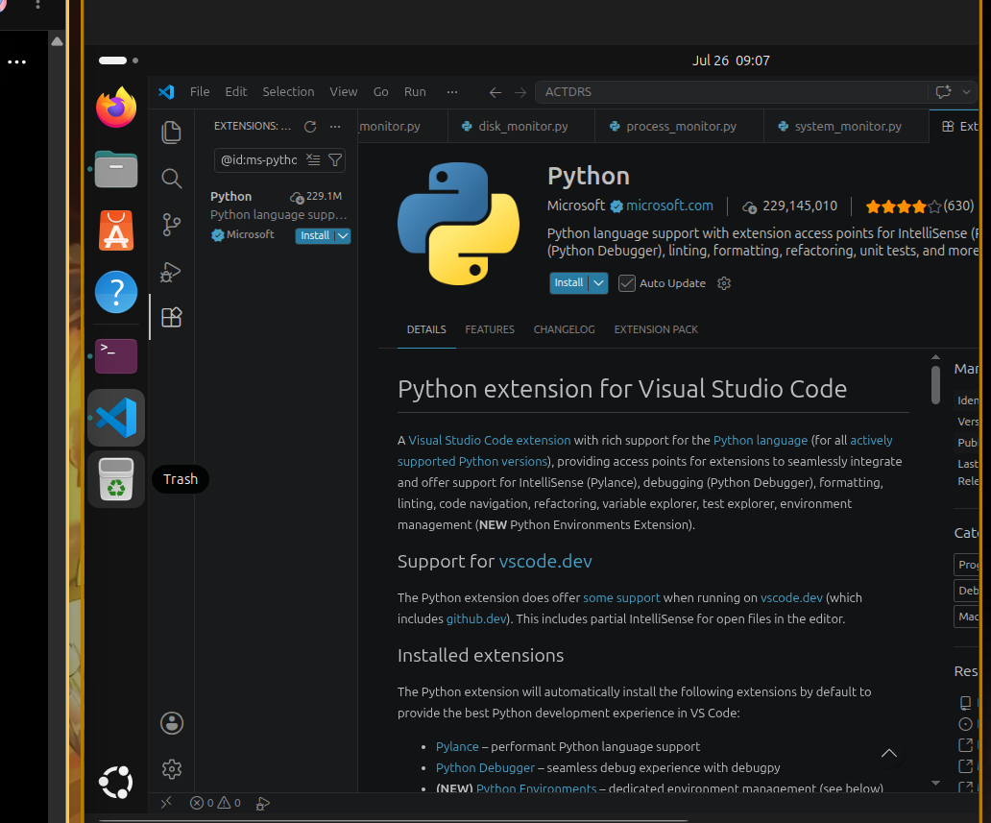
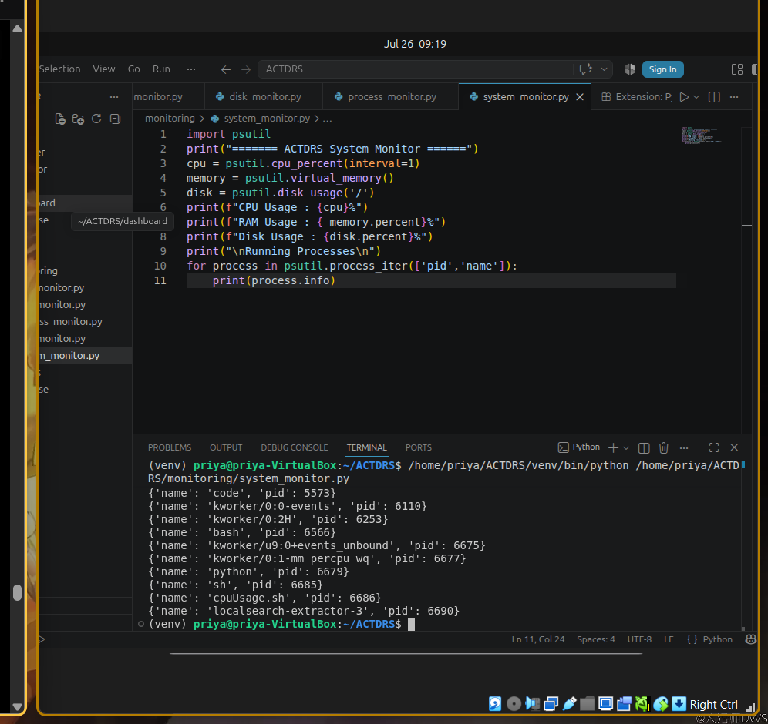Good question. Do not create a new page. Also, do not paste it below the existing for loop. Instead, we'll replace the current code with a better version.
Your current code is:
import psutil

print("====== ACTDRS System Monitor ======")

cpu = psutil.cpu_percent(interval=1)
memory = psutil.virtual_memory()
disk = psutil.disk_usage('/')

print(f"CPU Usage : {cpu}%")
print(f"RAM Usage : {memory.percent}%")
print(f"Disk Usage : {disk.percent}%")

print("\nRunning Processes\n")

for process in psutil.process_iter(['pid','name']):
print(process.info)
This runs once and exits.

Replace it with this
Delete everything in system_monitor.py and paste this:
import psutil
import time

print("====== ACTDRS System Monitor ======")

while True:

cpu = psutil.cpu_percent(interval=1)
memory = psutil.virtual_memory()
disk = psutil.disk_usage('/')

print("-----------------------------")
print(f"CPU Usage : {cpu}%")
print(f"RAM Usage : {memory.percent}%")
print(f"Disk Usage : {disk.percent}%")

print("\nRunning Processes\n")

for process in psutil.process_iter(['pid', 'name']):
print(process.info)

print("\nWaiting for next scan...\n")

time.sleep(3)

Why did we replace the code?
Because we want everything to repeat:
Read CPU
↓

Read RAM
↓

Read Disk
↓

Read Processes
↓

Wait 3 seconds
↓

Repeat
If you put while True: only below the for loop, then only part of the program would repeat, which is not what we want.

What happens now?
When you run:
python3 monitoring/system_monitor.py
Your terminal will continuously display something like:
====== ACTDRS System Monitor ======

-----------------------------
CPU Usage : 15%
RAM Usage : 42%
Disk Usage : 38%

Running Processes

{'pid': 1234, 'name': 'python'}
{'pid': 2345, 'name': 'bash'}

Waiting for next scan...

-----------------------------
CPU Usage : 18%
RAM Usage : 43%
Disk Usage : 38%

Running Processes

...
It will keep running until you stop it.

How do you stop it?
Since while True: runs forever, stop it by pressing:
Ctrl + C
in the terminal.

One small improvement
Printing every process every 3 seconds will flood the terminal with output. For learning, it's okay once, but it becomes hard to read.
For the next step, I'd recommend printing only CPU, RAM, and Disk continuously, and printing the process list only when we detect something suspicious. That's closer to how real monitoring systems behave and will make the output much cleaner.

